From the River Kwai to Kew: A journey of discovery
Ann Bennett discusses how she traced her father’s records of army service and reveals the wealth of documentary sources that have survived.
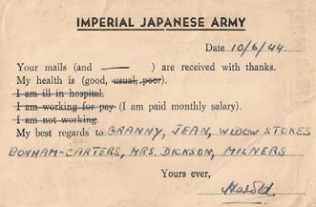Researching family history is a journey of discovery that can take you in many directions. There are different routes you can take: some are blind alleys and some super-highways to moments of enlightenment. This article is about my quest to find out about what happened to my father in the Far East during the Second World War. It took me on several trips to Thailand and also, thanks to the wonders of the Internet, to sources as far apart as Taiwan, the United States, London and Glasgow. It is a journey that is still not over - there are still avenues I would like to explore.

My father, Richard, or Dick Bennett, who had served as a Sub-Conductor1 in the Indian Army during the war, died in 1970 when I was only seven years old. In my early twenties I began searching for information about his wartime experience. I was aware of some vague facts: he had served in the army in Malaya, was captured by the Japanese at the fall of Singapore, and was enslaved on the infamous ‘Death Railway’. I knew he had survived the torpedoing of a Japanese transport ship off the Philippines, and lost a lung through breathing in burning oil.
All we had at home when I was growing up were two postcards that my father had sent to my grandmother during his years as a prisoner of war on the railway in Thailand. They were pre-printed and mass-produced for all prisoners to send home. Sadly, my father’s cards were lost at some point during the 1980s, but I can still visualise them. They were both along similar lines to the one reproduced above right. My father’s cards both showed that he was interned in Thailand No.1 camp. On one he indicated that he was working for pay, and
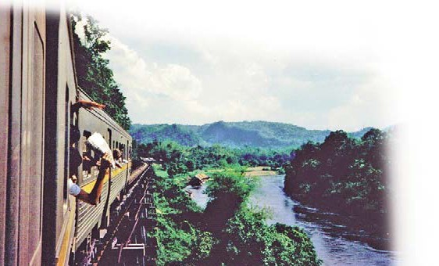on the second he said ‘I am ill in hospital’.
Since all we had were the cards, the starting point for my research was to find out what I could about Thailand No 1 Camp. A visit to the Imperial War Museum in Lambeth revealed some generic
Imperial Japanese Army postcard2
information about the camp. It was near the town of Kanchanaburi on the river Khwae Yai (or Kwai as we know it), temporary camps would have been thrown up in the jungle, work parties building the railway were moved around and very little would have survived to the modern day.
I first went to Kanchanaburi in 1988 with my mother to discover what we could about the railway. There was only one museum there at the time; the JEATH museum.3 It was and still is housed in a series of bamboo huts thatched with palm leaves, replicas of the ‘atap’ huts that the POWs would have lived in. JEATH stands for the six countries involved in the building of the Thai-Burma railway: Japan, England, Australia, Thailand and Holland. The museum was built by a Buddhist monk, Phramaha Tomsan Tongproh, chief abbot of the local temple, and contains photographs, first-hand accounts and general information about the camps and the conditions prisoners endured. A leaflet from 1988 states that the JEATH museum:
has been constructed not for the maintenance of the hatred among human being especially among the Japanese and the allied countries but to warn and teach us the lesson of HOW TERRIBLE WAR IS. MAY PEACE ALWAYS CONQUER VIOLENCES. [sic]
It is a fascinating and unique place. However, although the visit brought home to me the dreadful conditions the men suffered, it told me nothing more about where my father had been as it holds no information about individual prisoners.

The Wampo viaduct, constructed in 1943, is a series of trestle bridges

26

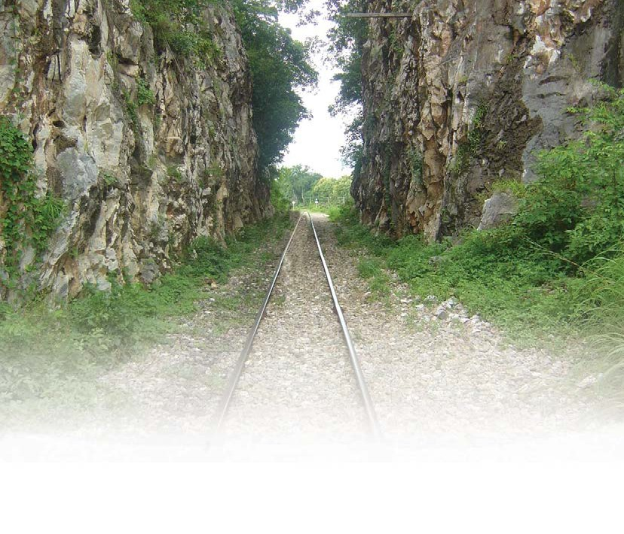The Chungkai cutting

Twenty-six years on there is far more information available in and around Kanchanaburi. The Thai-Burma Railway Centre,4 established and run by Australian engineer Rod Beattie, is a fantastic source of information. There is also the Hellfire Pass Memorial Museum5 built by the Australian Government in 1998, around eighty kilometres up the line from Kanchanaburi, at Hellfire Pass. This was the place where so many Australian POWs lost their lives during the notorious months of 1943, when the Japanese introduced a ‘Speedo’ period to meet tight deadlines for completing the work.
My mother gave me a copy of my father’s army record he received on his discharge on health grounds following his return from the Far East in 1946. It showed that he enlisted on 4 March 1932 in the Royal West Kent Regiment. There is also a testimonial, presumably designed to show to prospective employers:
An excellent type. Honest, sober and absolutely trustworthy. A keen steady and willing worker who has plenty of intelligence, ability and initiative. He is thoroughly reliable and can be recommended for any position of trust and responsibility.
The record showed that he was posted to India in December 1934, remained in the Royal West Kent Regiment in India until 30 June 1939, and was then transferred to the Royal Scots Fusiliers. He stayed with the Royal Scots Fusiliers until 14 February 1942 and is shown as being ‘in Japan’ between 15 December 1942
and 1 December 1945. He was discharged on 11 December 1946 with the rank of Sergeant, for ‘ceasing to fulfil army physical requirements’.
The Army personnel records are held by the Ministry of Defence and available from the Army Personnel Centre, Civil Secretariat, Historical Disclosures in Glasgow. I applied for my father’s records by completing a search questionnaire, a Certificate of Kinship and providing a copy of his death certificate. The accompanying letter with his records explained that when he had applied for his pension, part of his records had been sent to the Ministry of Pensions and either mislaid or destroyed. The file was incomplete but the available information gave flesh to the bones of the Army record.
This was a blow, but the information that was in the files gave flesh to the bones of the army record. The entries are meticulously made in pen and ink in beautiful flowing writing, demonstrating the enormous bureaucracy that kept the army and the empire going. The letters and entries confirmed the dates of his enlistment, travel and transfers. It also confirmed a family rumour that my father had deserted from the Army a year or so after joining the Royal West Kent Regiment and that he was not recaptured for nine months. His punishment was 56 days’ detention and he was ‘placed under stoppages of pay’. This sentence was suspended after 27 days, and finally remitted altogether when he went to India.

There are also several letters on the file from 1946, between the Royal Scots Fusiliers in Perth, the Ministry of Pensions, the Royal Hospital, Chelsea, London SW3, and the Indian Army in Meerut, attempting to ascertain my father’s precise rank in order to clarify how much back-pay he was due for his three and a half years as a prisoner of war. The result of all this correspondence is that he received a pension of 21 shillings and 2d (two pence) per week for life from 12 December 1946. He was discharged from Horton Emergency Hospital, Epsom on 3 August 1946 as being permanently unfit for any form of military service.
Later, I visited the Imperial War Museum, Department of Documents reading room several times and read many first-hand accounts and diaries (or service journals) of other soldiers enslaved on the death railway. These are the most harrowing of accounts – beatings, starvation, illness, and brutality.6 Like the JEATH museum, this showed me more of what my father had witnessed and suffered during his time a prisoner, but nothing about where he had been or what had happened to him personally.
By the time I returned to Kanchanaburi in 2005, the Australian Government had funded the restoration of parts of the railway by volunteers. A walking trail had been established making it possible to walk from the Australian Memorial, through Hellfire Pass itself and up to Hintok, past the infamous ‘pack of cards bridge’, compressor cutting and ‘hammer and tap’ cutting.

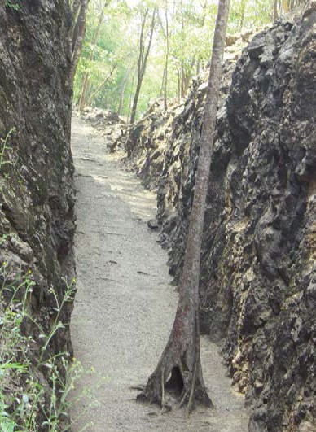Hellfire pass

28

I thought at that stage that I knew as much as I was ever going to know about what happened to my father during the war. But in 2010 I did some Internet research and came across the Far East Prisoners of War Community.7 I posted on the community message board asking if anyone had information about my father. Some members of the community tried to help but the answer came back that he was unlikely to have been at the fall of Singapore because the Royal Scots Fusiliers had not actually been in Singapore in February 1942; they fought in the Burma campaign in India. This felt like a big set- back. I felt sure that Dad had been in Singapore. I certainly knew he had been a prisoner of war – his records said so, but the post cards that had been lost in the 1980s were the only proof that he had been on the ‘Death Railway’.
After a few days of uncertainty there was a breakthrough. A member of the community confirmed that records showed that my father was one of about 1300 British and Dutch POWs transported from Singapore aboard the Hofuku Maru on 4 July 1944. His message went to say:
The ship suffered engine troubles and eventually limped into Manila. No one knows for sure how many died aboard ship in transit or in harbour (my guess is about 20) but 71 men were taken ashore to the ‘hospital’ at Bilibid where 10 died. The remaining 1200 or so prisoners sat in the harbour until 20 Sept 44 when they sailed north for Japan. The ship was intercepted by American carrier planes the next day and sunk off the west coast of Luzon with the deaths of about 900 POWs.8
The message continued that my father was one of 221 survivors who were taken back to Bilibid in Manila (others went to Canatabuan or Taiwan and several escaped with Filipino guerrillas). He stayed there until 1 October 44 when he was put aboard another ship, the Hokusen Maru along with 1100 others (mostly Americans). This ship made a tortuous 39 day voyage to Taiwan (via Hong Kong) where the POWs finally disembarked. My father stayed on in Taiwan and was liberated from Shirikawa camp.
A few days later, Michael Hurst, president of the Taiwan POW Camps Memorial Society,9 confirmed this information via the FEPOW community. He also solved the mystery about the Indian Army connection. My father had transferred from the Royal Scots Fusiliers to the Indian Army Ordnance Corps. Michael added that when the Hokusen Maru arrived in Takao (present day Kaohsiung) the men were off-loaded and sent to various camps to recuperate before later being moved on to Japan in mid-January 1945. My father was sent to Shirikawa camp in south-central Taiwan. Michael kindly sent a colour copy of the extract from the Honour Roll of the camp roll showing my father’s name.
The FEPOW community also put me in touch with Robert Hudson, a US citizen, who had researched the US National Archives and obtained the list of prisoners

on board the Hokusen Maru. He confirmed that my father was on his database that had been retrieved from the US National Archives. It was partly on 65 year-old microfilm, and partly on tiny pieces of paper that he had photographed. He sent me a link to his database,10 which contained the names of the 282 prisoners POWs who survived the sinking of the Hofuku Maru including my father’s name. He confirmed that my father was taken to Cantabuan POW camp and boarded the Hokusen Maru on 1 October 1944 and departed from Pier 7 in Manila on 3 October.
Michael Hurst encouraged me to visit The National Archives in Kew and search for my father’s liberation questionnaire and Japanese record card. I had not known previously that at the end of the Second World War newly released prisoners of war were required to complete liberation questionnaires. These were first made available to the public in 2005, but not all prisoners had completed one, and of those who did, most had only completed the first page. There are over 30,000 questionnaires, held in 98 files at The National Archives, filed in WO 344. The archive also contains record cards, in WO 34, kept by the Imperial Japanese Army to record the movements of each prisoner. Both my father’s record card (mainly in Japanese) and his liberation questionnaire (written by him in pencil and complete) were there. It was an amazing moment when I first saw those records; they answered so many questions I would have liked to ask.
In his liberation questionnaire he gave full details and dates of all the camps he had been in, that his unit was HQ 3 India Corps, and the place and date of capture - Singapore 15 Feb 1942. He listed the prison camps as follows:
Changi (Singapore) Feb-Oct 1942 Wan Lung, Thailand Nov-Dec 1942 Wantakin Dec 42-March 43
Pookai April 43
Tarso May 43
Tamarkan May-Nov 43
Chungkai Dec 43-June 44 Shirakawa, Formosa Nov 44 - Aug 45
The liberation questionnaire revealed a great deal about his experience as a POW. He wrote in answer to a question about whether he had witnessed an escape attempt:
Four men made an attempt in Jan or Feb 43, were brought back to Chungkai, Thailand, tried and shot in conditions of great secrecy. It was rumoured they had killed a Thai. Their graves are at the foot of a rocky hill and about 400 yards north of a small Thai village and school which is situated on the north side of the railway line. I do not remember their names or units.
In answer to a question about whether he was aware of any sabotage attempts he wrote:

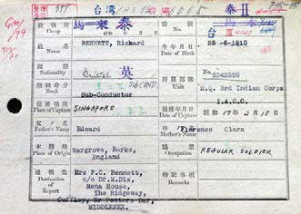

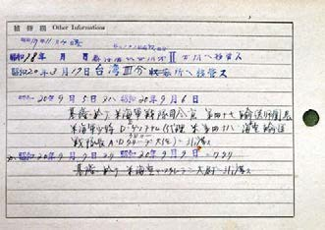

WO 345/4: Japanese Imperial Army record (front and back)

Many large bamboo roots were put in the embankment on the Thailand Railway near Wan Lung about the beginning of December when the Japanese were not looking, with a view to rendering it unsafe.
He was asked to describe any courageous acts he had witnessed and wrote that:
Lieut. Cox: Royal Norfolk Regiment. On 21st September 44, when a Jap ship containing prisoners of war was sinking he, with complete disregard for his own safety, and under MG fire from American aircraft, helped men out of the hold while the boat was sinking, and by so doing lost his own life (consult CSM Kerr - 2 Cambridgeshire for corroboration, as Lieut, Cox helped him out of the hold).
I consider the old Thai woman who gratuitously tended the graves mentioned above should be suitably recognised and rewarded.
I had the record card translated from Japanese into English. It confirmed some of the details of dates and movements on the questionnaire and revealed that on 5 and 6 September 1945 my father had been turned over to the American Navy commander of the 47th Transportation Division at Keelung (a port in Formosa, now Taiwan).

Alongside my research I also read as much as I could about the Death Railway. The best books I found were Surviving the Sword, by Brian McArthur,11 the Prisoner List, by Richard Kandler,12 and The Colonel of Tamarkan, by Julie Summers.13 Death on the Hellships, by Gregory Michno14 an American historian, is a meticulously researched book on the movements of all Japanese transport ships and gathered accounts of the survivors. The book contains detailed passages about the sinking of the Hofuku Maru, and conditions onboard both ships. Reading those accounts was a painful experience.
On my next trip to Thailand, in 2010, Terry Mantann of the Thai-Burma Railway centre arranged a day’s ‘pilgrimage’ to Kanchanaburi, for me and my eldest son. We spent the day visiting the sites of some of the camps on my father’s liberation questionnaire, and saw the site of the execution that my father had described. We also went to the Chungkai cutting chipped out by hand by the prisoners - the marks made by their chisels were visible.
The British Library holds Indian Army records and for a small fee I was able to obtain a copy of my father’s Indian Army file.15 This file gave a great deal of information about his time in India. For example, he arrived on board the troopship Neuralia on 18 December 1934. He served in 1935 and 1936 in Secunderabad at the HQ of the 9th Indian Division, in Loralai (on the North- Western Frontier of the Empire with Afghanistan), in Quetta and Karachi. The file confirmed that was in the Malayan campaign under India III Corps and was reported as taken prisoner on 15 February 1942. It also contained the mirror correspondence in 1946, concerning his precise rank for his back pay after the war and confirms that he was recovered from enemy hands on 15th August 1945.
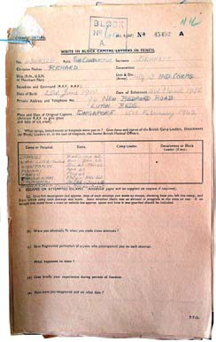There are still avenues I would like to explore – there are likely to be records relating to the Indian Army in New Delhi. I would also like to find out more about the role my father’s unit played in the Malaya campaign. In the meantime, I wanted to find a way of making sense of everything I had discovered. I had always loved creative writing, so I decided to take the tragic events my father had described in his question- naire and weave them into a story about a prisoner on the ‘Death Railway’. I wrote it in parallel with the story of his daughter who embarks years later on a quest to find out what happened to her father during the war. It took

book went through many drafts. I called it Bamboo Heart, after a heart condition suffered by many POWs.16
Notes:
- Indian Army equivalent to Warrant Officer;
- Reproduced with the kind permission of Andrew Harpham;
- New Zealand Rd., Tha Ma Kham, Mueang Kanchanaburi District, Kanchanaburi, Thailand;
- T.B.R.C. Co., Ltd, 73 Jaokannun Road, BanNua, Amphoe Muang, Kanchanaburi 71000, Thailand;
- http://hellfire-pass.commemoration.gov.au/remembering-the- railway/hellfire-pass-memorial-museum.php;
- The reference departments at the Imperial War Museum can provide general information and may give some interesting clues. Resources include rare books, official publications, unit histories, service journals, service lists, rolls of honour, graves registers, maps, personal papers, campaign and gallantry medals, photographs, film and sound recordings;
- http://www.fepow-community.org.uk/;
- Subsequent checking has shown that there were 1047 POW casualties and 282 survivors;
- http://www.powtaiwan.org/The%20Society/index.php;
- http://www.battlingbastardsbataan.com/bob1.htm;
- Abacus, 2006;
- Marsworth, 2010;
- Pocket Books, 2006;
- US Naval Institute Press, 2001;
- See
http://www.bl.uk/catalogues/indiaofficeselect/welcome.asp;
- The book was published in May 2014, by Monsoon Books in South East Asia, and published in the UK in October 2014. www.bambooheart.co.uk
The author is grateful for the help and support of FEPOW during her research.

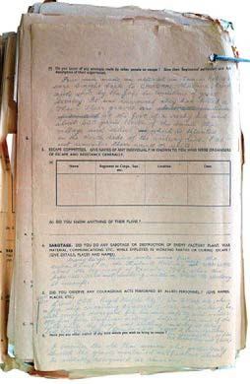several years to write and the WO 344/364/2: Liberation questionnaire (front and back)

30

